Activities Include:

* Physical Activities to include

P.E. and Gymnastics

* Dance and Music Activities
* Arts & Crafts (Creative Construction)
* Story Time, Drama, and Movies
* Picnic and Outdoor Activities
* Water Day
* Academic Reinforcement and more…..

Program includes daily snack and Friday’s special treat. Lunch needs to be provided by parents.

**Program Hours:**

Full Time: 8:30 a.m. to 3:00 p.m.

Part Time: 8:30 a.m. to 12:00 p.m.

After Care: 3:00 p.m. to 6:00 p.m.

Session 2

(4 Weeks)

July 18th – July 22nd

July 25th – July 29th

August 1st – August 5th

August 8rd – August 12th

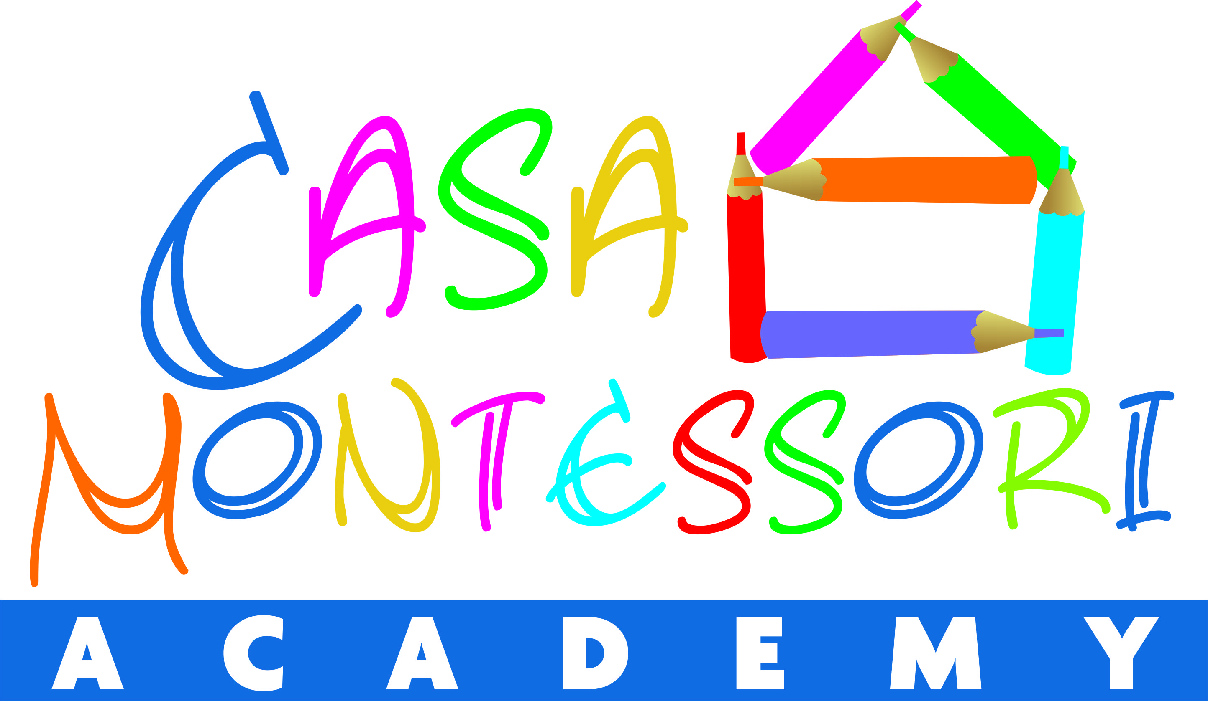

*Registration Fee of $50.00 includes all materials. This fee is non-refundable.*

*Students will be required to buy shirts for the summer program.*

*One and two weeks only - $130.00/week.*

*Registration for one Session - $120.00/week.*

*Registration for both Sessions - $110.00/week.*

*Before and after care per hour or per week and siblings’ discounts available!*

**12200 SW 56th Street – Miami, FL 33175**

**Please call us at 786.763.3842**

***Program***



**Register Right**

**Now !**

**Early registration by May 22nd  *$35.00***

Session 1

(4 Weeks)

June 20th – June 24th

June 27th  – July 1st

July 5th  – July 8th

July 11th  – July 15th

**The Focus of our camp is to fulfill their curiosity, express creativity, and exercise their brain and their muscles!!! Hands on activities led by experienced personnel to help build self-confidence and motivate a child’s cognitive, language, social, emotional and Physical development.**

Come and Join us in an adventure full of recreational and educational fun!!!!!

June 20th, 2016 to August 12th, 2016

Eight weeks of fun activities for your children to enjoy the summer!